Test assignment for an applicant for a position in the parsing team

* Create a function that will output a list of requested positions/needs from “Stillingskategori” section in “source_document_for_multiple_needs__roles_with_positions_amount.docx” file,  
    
  where requested positions/needs correspond to numbers   
  before each role name  
  e.g. “2 helesfagarbeider” meaning that needed 2 people with role `helesfagarbeider`  
  The answer should be in the following format: [Role1, Role2, Role2]  
  listing all people required with role names.   
  Recommended / suggested tools (to use) for this task: python-docx (or similar library), regexp
* Create a function that will output the deadline datetime from “source_for_extract_deadline_date_time.html” file.   
  Deadline should be extracted from the highlighted text:  
  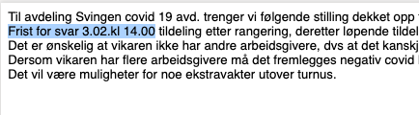  
  The answer should be in the following format: '1999-12-31T23:59:59'.  
  Recommended / suggested tools (to use) for this task: Beautiful Soup (or similar library) and / or regexp, datetime